Name _______________________________

C # _________________________________

Dual Credit Information for Students

MyIvy Accounts and Passwords
Campus Connect is a one-stop web portal for Ivy Tech students and Dual Credit students, which provides access to the following:
- Check your grades online (grades for dual credit courses typically are not accessible until 30-60 days after the end of the semester)
- Free Ivy Tech e-mail
- Virtual library
- View your unofficial transcript

Accessing MyIvy - First Time Users
- To setup your account for the first time, visit https://myivy.ivytech.edu/ Click on First Time User.

- Click on the I Agree button on the Acceptable Use Policy page. Enter the following pieces of information:
  - First name
  - Last name
  - Student ID (this is the Ivy Tech C#)
  - Your date of birth in mmddyyyy format
  - The zip code of your current mailing address.
- You must now choose a new password. Your password must include at least one capital letter, at least one number, and one special character (!, ?, +, -, %) and needs to be a minimum 8 characters long. Your password cannot begin with a special character. Click Next.
- Please answer the following security questions when prompted. Click Next when finished.
  - What is your mother's maiden name?
  - What is your city of birth?
  - What is your favorite color?
  - What is your favorite band?
  - What is your first pet's name?
  - What are the last 4 digits of driver's license?

Forgotten Campus Connect Username or Password
If you don’t know or cannot remember your username, visit https://myivy.ivytech.edu/ and click on the “Forgotten Username?” link or call 1-888-IVY-LINE.

Withdrawal from a Dual Credit Course
You must notify your high school dual credit instructor and complete the appropriate Ivy Tech form to withdraw from a course. You may officially withdraw beginning at the start of the third week of the Ivy Tech semester up to the end of the week marking the completion of 75% of the Ivy Tech semester.

Obtaining a Transcript
A free unofficial Ivy Tech transcript can be obtained by logging into MY IVY at https://myivy.ivytech.edu/

Unofficial Transcripts
Unofficial transcripts are available via the online student portal for current students:
- Log into your MyIvy account (myivy.ivytech.edu)
- Select "Student" (left hand side)
- Select "Course Info"
- Then, select "Unofficial Transcripts"

To obtain an official copy of your Ivy Tech transcript, either visit your local Ivy Tech Registrar’s office or go to http://www.ivytech.edu/registrar/transcripts.html. You will need to fax or mail this form. There may be a fee charged for each official transcript.

Assessment
If you do not have a qualifying ACT, SAT or PSAT score, you will need to take the ACCUPLACER skills assessment. You must meet certain score criteria in order to receive dual credit for high school classes. We will set up a time with your school guidance counselor or teacher to administer the Accuplacer testing at your school and they will let you know when you will be testing.

To prepare for the Accuplacer test, you can log on to http://www.ivytech.edu/assessment/. You will find links to study guides, sample questions, and practice tests.

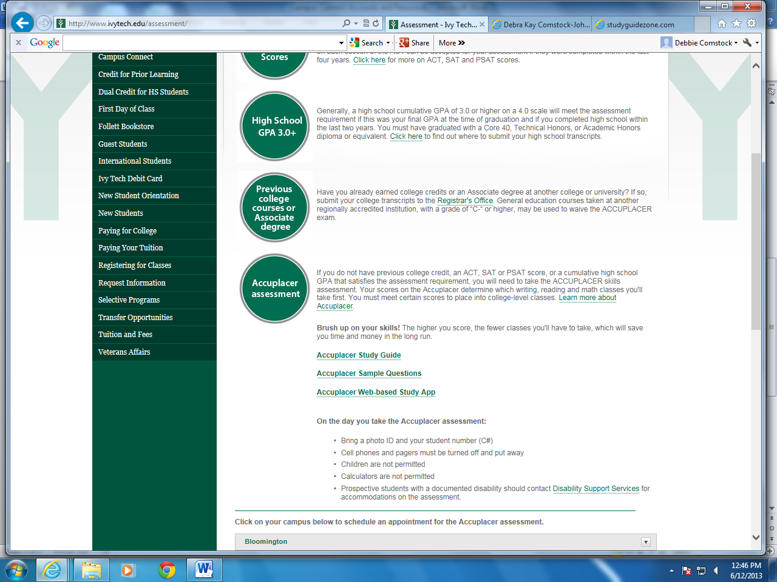
Contact Information

Stephanie Ebbing
Sheana Harmon
Seymour High School
School Counselor
Dual Credit Coordinator
Email: harmons@scsc.k12.in.us

Assistant Director K-12 Initiatives
(812) 374-5122
Email: sebbing@ivytech.edu

Lana Rankin
Dual Credit Advisor
(812) 374-5329
Email: lrankin@ivytech.edu

